Design Document Specification

TRAVEL ADVISOR WEB APPLICATION

version 1.0

creation date: 6-5-2019

Authors: Nesma Bahgat – Asmaa hamdy – maysoon maagdy – mahmoud yasser – esraa salah – sara sayed

2019

Table of Contents

**1 INTRODUCTION2**

**2 PURPOSE2**

**3 HIGH LEVEL DESIGN3**

3.1 SYSTEM ARCHITECTURE3

3.1.1 DESCRIPTION4

3.2 USE CASES5

3.2.1 DESCRIPTION6

**4 LOW LEVEL DESIGN**

4.1 DETAILED DESIGN

4.1.1 CLAS DIAGRAM

4.1.2 DESCRIPTION

4.2 DATA MODEL

4.2.1 ERD

4.2.2 MAPPING

**5 USER INTERFACE**

5.1 WIREFRAMES

5.1.1 DESCRIPTION

5.1.2 CONSTRAINTS

5.1.3 ERROR AND SUCESSFUL MESSAGINGS

1 introduction

This System Design Document has been created to outline the proposed system design for Travel Advisor Web Application (TAWA). TAWA is intended to provide the top traveler destinations to users and guide them through from the start to the end of the journey.

2 PURPOSE

The purpose of this System Design Document is to provide a description for how the TAWA will be constructed. The System Design document is created to ensure that the TAWA design meets the requirement specified in the TAWA project requirements documentation. The System Design Document provides a description of the system architecture, user interfaces, database design, detailed design and data models.

3 High level design

3.1 system architecture

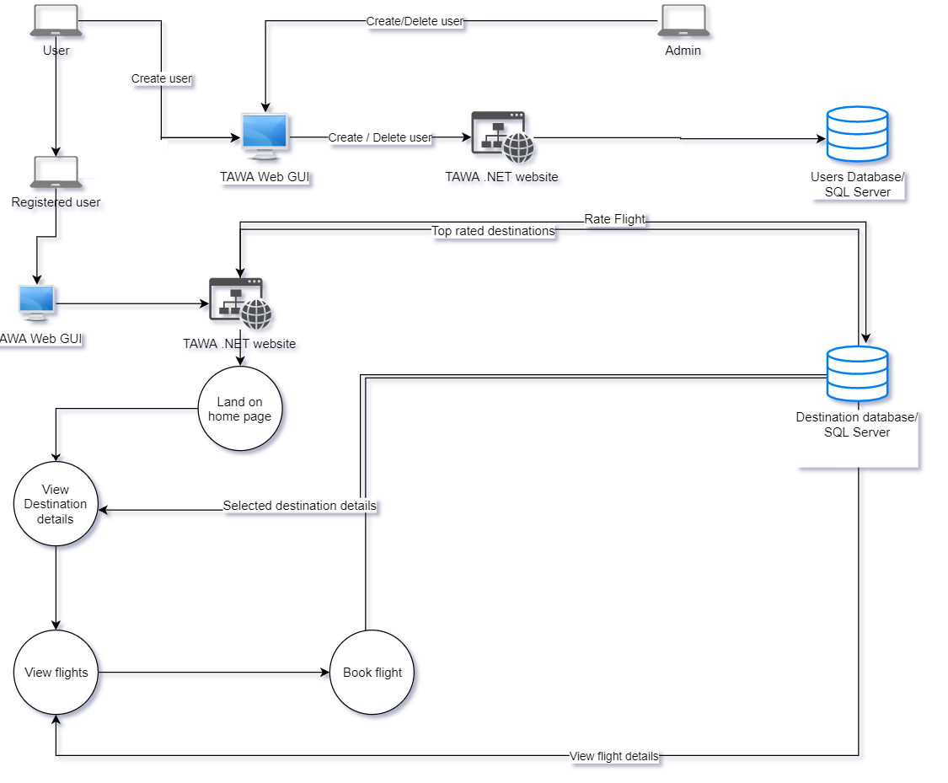

Figure

3.1.1 description

* Purpose: **High-level design** (HLD) explains the architecture that would be used for developing a software product.  
  A high-level design provides an overview of a solution, platform, system, product, service or process.  
  Such an overview is important to make sure that each supporting component design will be compatible with its neighboring designs and with the big picture.
* In Figure 1 which describe the whole system architecture there is an abstract overview for what the system shall do.
* Both admin and normal user can create new user but admin has more privilege to delete another user. This will eventually affect the users database (SQL SERVER)
* Registered User can navigate through the .Net application supported by web GUI to do many available functions.
* Registered User can land on the homepage which will inform him about the top-rated travel destinations (directly comes from SQL SERVER destination database).
* Registered User can view flights details and choose what is the best airline and flight for him.
* Registered User can book a flight using the .NET application that will affect the SQL SERVER destination database.
* Finally Registered User can rate the flight, this will affect the next traveler choice because it will change the top-rated travel destinations accordingly.
* 3.2 USE CASE

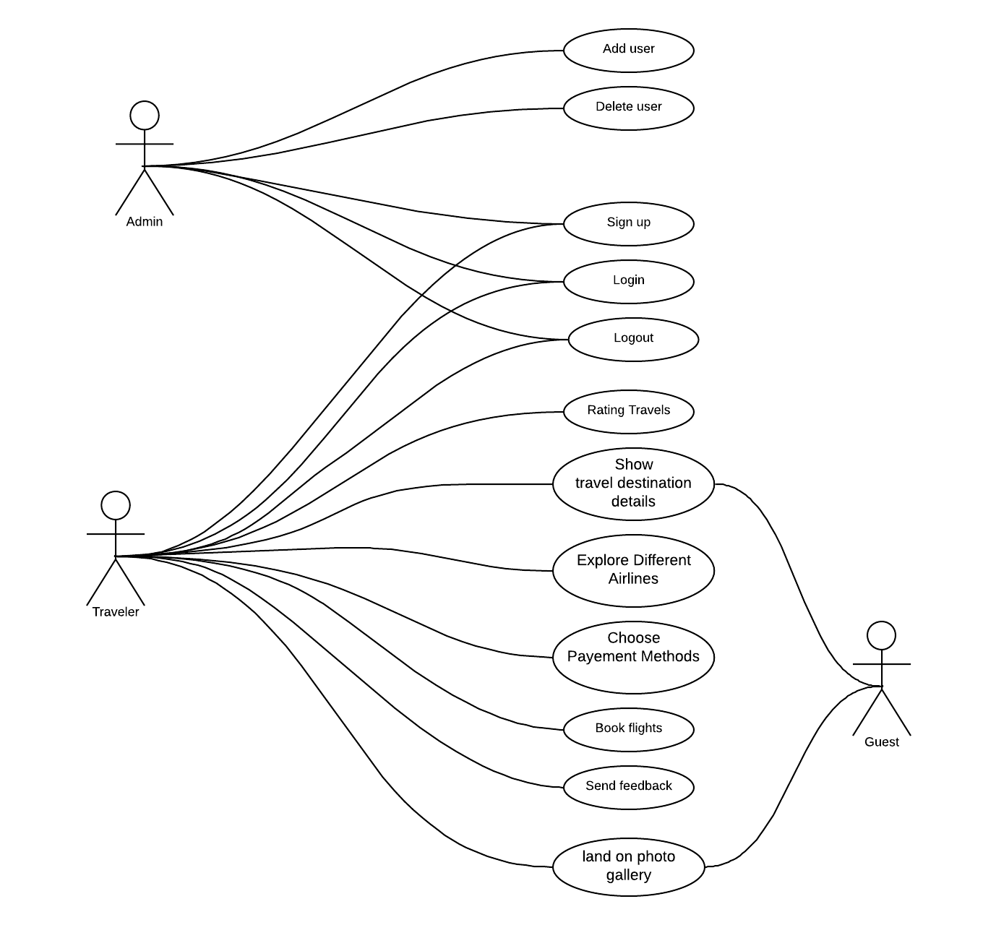

3.2.1 description

* Purpose: The purpose of use case diagram is to capture the dynamic aspect of a system by showing the interaction between the system and it’s actors.
* In this application we have three actors (Admin, Traveler and guest) each actor has his own functionalities.
* Both admin and Traveler are allowed to perform the next functionalities (Signup / Login/ logout ).
* Only the admin has the (Add user / Delete User ) Functionalities
* Both Traveler and guest are allowed to land on the photo gallery and show travel destination details.
* Only Traveler can do the next functionalities (Rating Travels / Explore Different Airlines / Choose Payment Methods / Book Flights Send Feedbacks).

5 user interface

5.1 wireframes

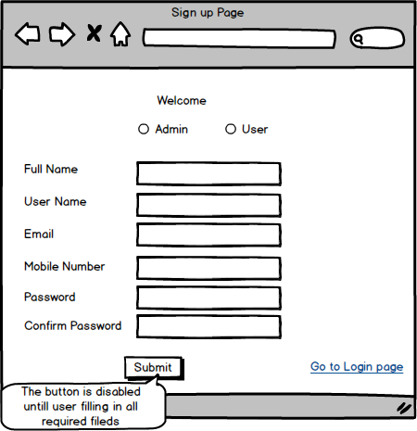

TAWA_WF_01

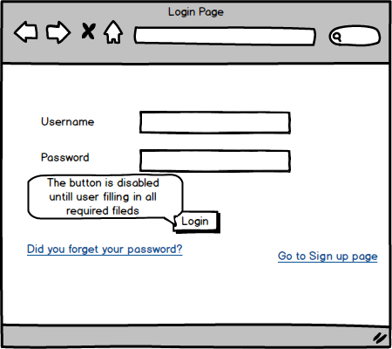

TAWA_WF_02

TAWA_WF_03

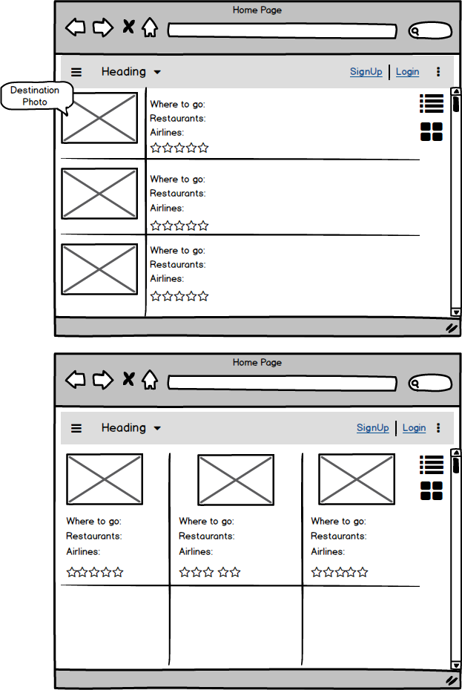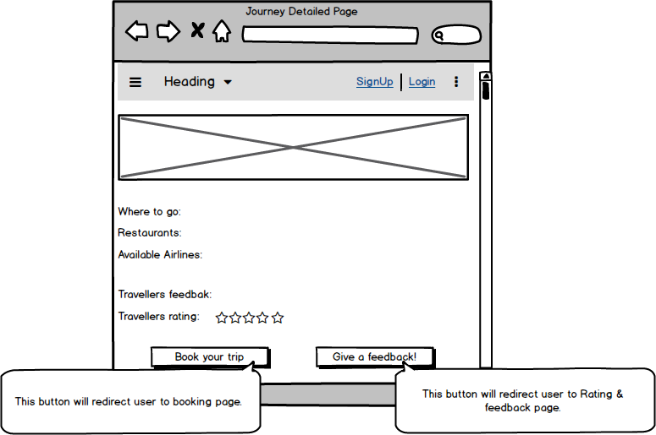

TAWA_WF_04

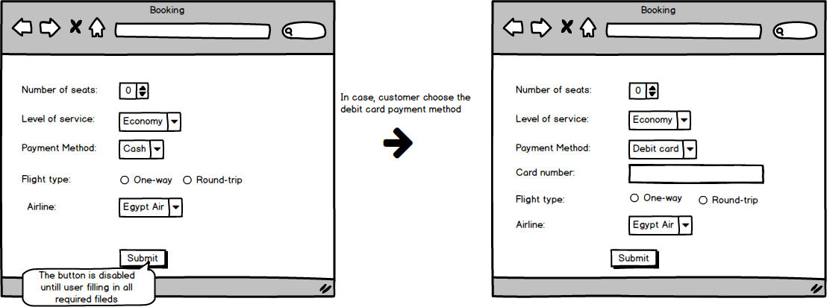

TAWA_WF_05

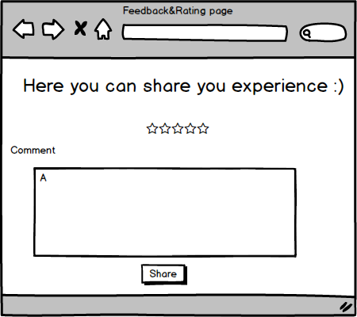

TAWA_WF_06

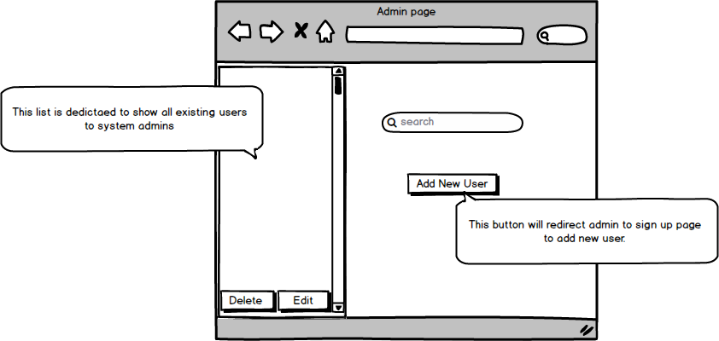

TAWA_WF_07

5.1.1 Describtion

|  |  |
| --- | --- |
| ID | Description |
| TAWA_WF_01 | This is the Signup page, where users and admin can register to TAWA. |
| TAWA_WF_02 | This is the Login Page, where users and admins can login to TAWA. |
| TAWA_WF_03 | This is the Home Page, where users will be redirected to after logging in and users will land on a gallery photo shows the top traveler destination.  User can choose to view the page with list view or grid view. |
| TAWA_WF_04 | This is the Journey Detailed page, where the user will find all information about the place he chose in addition to previous traveler feedbacks and the average rating for the trip. |
| TAWA_WF_05 | This is the booking page, where users can book their flights. |
| TAWA_WF_06 | This is the feedback and rating page, where the user can write down his feedback and rate the journey to be shared with other travelers. |
| TAWA_WF_07 | This is the admin control page, where the admin can do his actions (add / delete users). Admin can delete or edit user by selecting the user from users’ list and take the required action. |

5.1.2 CONSTRAINTS

|  |  |  |
| --- | --- | --- |
| ID | Field | Constraint |
| TAWA_WF_01 | Full Name | 1-Accepts characters and spaces only.  2-Max length is 24 character. |
| User Name | 1-Accepts characters, numbers and special characters.  2-Shall be unique.  3-Max size is 14 character. |
| Email | Max size is 24 character |
| Phone | 1-Accepts numbers only.  2-Max size is 20. |
| Password | 1-Shall be complex (Upper case and lower case character, numbers and special characters).  2-Shall be masked.  3-Min size is 8 characters. |
| Confirm Password | 1-Shall be masked. |
| TAWA_WF_02 | User Name & Password | Mandatory fields. |
| TAWA_WF_05 | Card number | Shall be 12 number. |
| Airlines | User shall choose between (Egypt Air, Fly Emirates, Qatari Airways, Turkish Airlines, Lufthansa and Air France). |
| Service level | User shall choose between (Economy - Business - Luxurious). |

5.1.3 eRROR AND SUCcESSFUL MESSAGINGS

|  |  |
| --- | --- |
| ID | Messages |
| TAWA_WF_01 | 1-In case of user didn’t enter data or entered wrong data in any field, an error message should display with "The data entered were invalid, Please re-enter your data." |
| 2- In case of user/admin entered a username which already exists, an error message should display with "This username is already reserved. Please enter a different username". |
| 3-In case of user registers successfully, a confirmation message should display with "Congratulations! A new account has been created successfully". |
| In case of user entered weak password, an error message should display with "Password should contain upper and lower case, special character and more than 8 characters". |
| In case of user entered in “confirm password” field different password from “Password” field, an error message should display with "The data entered were invalid, Please re-enter your data." |
| TAWA_WF_02 | In case of user didn’t enter data or entered wrong data in any field, an error message should display with "The data entered were invalid, Please re-enter your data." |